Bordeaux 101

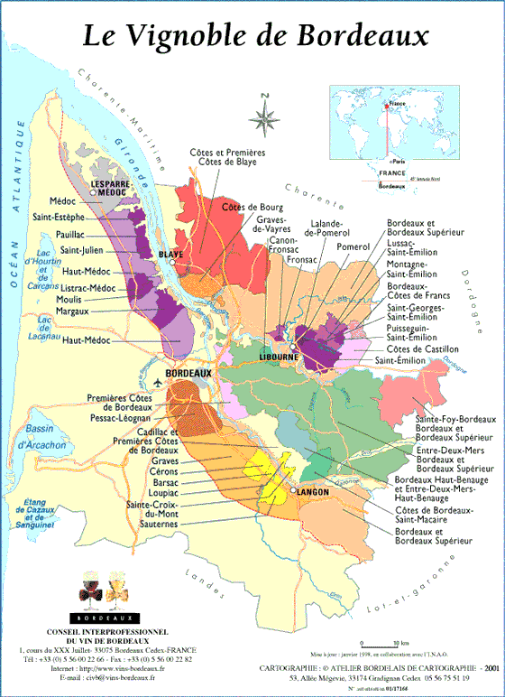

The Rivers and the Banks: The left fork of the Gironde is the Garonne; the right fork is the Dordogne. The Left Bank lies west of the Gironde and Garonne; the Right Bank is east and northeast of the Dordogne. In the middle is Entre-Deux-Mers.
Wines and Grapes:
Reds: A blend of Cabernet Sauvignon, Merlot, Cabernet Franc, Petit Syrah, & Malbec.
Whites: A blend of Sauvignon Blanc, Semillon, & Muscadelle.
Most Important Bordeaux Red Wine Districts:
Left Bank: Haut-Médoc (The Haut-Médoc is further subdivided into communes: St. Estèphe, Pauillac, St-Julien, and Margaux.); Graves
Right Bank: St-Emilion; Pomerol
The Left Bank has predominantly gravel soil, while the Right Bank has predominantly clay. As a result, the principal grape variety on the Left Bank is Cabernet Sauvignon, while Merlot is more dominant on the Right Bank. In general, the Left Bank wines are more austere and tannic, with a black currant flavor. Many will age for years, often decades. The Right Bank wines are less tannic, richer in flavor (more plummy).
Classified Growths: In 1855, the Bordeaux Chamber of Commerce developed a classification of Bordeaux wine châteaux (all Médoc except Haut-Brion, from Graves) based on their perceived quality. There are 5 crus, or growths, comprising 61 wines. The 5 First Growths (top cru) are: Château Lafite-Rothschild, Château Latour, Château Margaux, Château Haut-Brion, Château Mouton-Rothschild (promoted in 1973)
There are other, more recent classifications specific to Graves, St-Emilion, whites, and, sweet wines, but these are far less prominent than the 1855 classification.
There are many châteaux that were not among the classified growths in 1855, or that have come into being since then. These are usually the sources of more affordable wines.
“Generic Bordeaux” – the Bordeaux and Bordeaux Supérieur Appellations:
These appellations apply to wines from vineyards that do not fall within the named appellations or otherwise meet rules entitling them to use those appellations. They are less expensive than most of the named appellation wines and are made to be consumed soon. There are more stringent criteria for Bordeaux Superieur appellation wines than for Bordeaux appellation wines. Wines from some of the larger, more spread-out appellations such as Entre-Deux-Mers and Premières Côtes de Bordeaux are also less expensive and exclusive.
White Bordeaux: There are two styles of white Bordeaux, dry and sweet. Both come primarily from the Graves and Entre-Deux-Mers regions. The most distinguished dry whites are from Pessac-Léognan in the northern Graves. The greatest sweet wine is from Sauternes, in the southern Graves.
A Few Other Recommended Wines, from winelibrary.com:
Chateau De Callac Graves Blanc 2006 (Graves, ~$16)
Chateau De Lavagnac Rouge 2005 (Bordeaux, ~$9)
Chateau Moulin De Lavaud 2005 (Pomerol, ~$19)
Chateau Callac Prestige Rouge 2005 (Graves, ~$16)
Web Sites: www.bordeaux.com ; http://www.terroir-france.com/wine/ ; http://www.greatwinecapitals.com/bordeaux

