AWS Cabernet Franc Tasting Notes

Mike and Mary Anne Wassenberg
Professional Friends of Wine: http://www.winepros.org/wine101/grape_profiles/cab-franc.htm
Recent studies in ampelography, using the relatively new application of DNA fingerprinting, have determined that Cabernet Franc is one of the genetic parents of Cabernet Sauvignon (the other is Sauvignon Blanc). Both Cabernet varieties are among the five major grapes of Bordeaux. The differences between Franc and Sauvignon become apparent when grown and fermented in close proximity.
Cabernet Franc vines bear thinner-skinned, earlier-ripening grapes with lower overall acidity, when compared to Cabernet Sauvignon. Yields are similar, although Cabernet Franc normally buds and ripens somewhat earlier. Consequently vineyards in climates where rain is a harvest-time threat often plant this grape, rather than or in addition to Cabernet Sauvignon. Cabernet Franc vines survive cold winters better than Cabernet Sauvignon, but are more susceptible to being damaged by Spring frosts.
France has by far the most Cabernet Franc plantings of any wine producing nation with over 35,000 acres. There are significant plantings of Cabernet Franc in St. Emilion, the Loire Valley (where it is known as Breton), and southwest France (aka Bouchy). There are Cabernet Franc vineyards in Romania, Hungary, the Balkans, and the Friuli region of north eastern Italy (aka Cabernet Frank). New plantings in the 1990s in Australia, New Zealand, and Argentina show promise. In the United States, Cabernet Franc is planted in Long Island, New York, and in Washington state. California has about 2,000 acres, mostly planted since 1980, over half in Napa and Sonoma.
Depending a great deal on vineyard practices, the flavor profile of Cabernet Franc may be both fruitier and sometimes more herbal or vegetative than Cabernet Sauvignon, although lighter in both color and tannins. Over-cropping and underexposure each tend to accentuate the vegetative flavor elements. Typically somewhat spicy in aroma and often reminiscent of plums and especially violets, Cabernet Franc is more often used as a secondary or tertiary element in varietally-blended red wines, such as Bordeaux or Meritage, instead of as a stand-alone varietal bottling.
Typical Cabernet Franc Smell and/or Flavor Descriptors
Varietal Aromas/Flavors: | Processing Bouquets/Flavors:
Fruit: raspberry, cherry, plum, strawberry | Oak (light): vanilla, coconut, sweet wood
Floral: violet | Oak (heavy): oak, smoke, toast, tar
Herbal: bell pepper, stems | Bottle Age: musk, mushroom, earth, cedar, cigar box

Berry Bros & Rudd: http://www.bbr.com/HK/db/grape-variety/CF?first_product_F=1&ID=null
Cabernet Franc is widely planted in Bordeaux and is the most important black grape grown in the Loire. In the Medoc it may constitute up to 15% of a typical vineyard. It is always blended with Cabernet Sauvignon and Merlot and is used to add bouquet and complexity to the wines. It is more widely used in St.Emilion where it adapts well to the cooler and moister clay soils. Cheval Blanc is the most famous Cabernet Franc wine in the world, with the final blend consisting of up to 65% of the grape.

Cabernet Franc thrives in the Loire where the cooler growing conditions serve to accentuate the grape's herbaceous, grassy, lead pencil aromas. The best wines come from the tuffeaux limestone slopes of Chinon where growers such as Charles Joguet produce intense well-structured wines that possess excellent cellaring potential.

Horton, Virginia, 1998
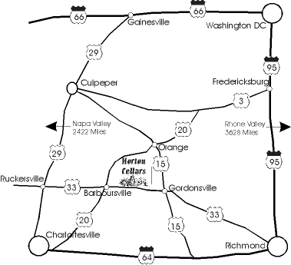
- Horton Cabernet Franc is the first in the United States using the traditional blending variety, Tannat. The result is a wine with a firm structure and a spicy finish.
- 92% Cabernet Franc, 8% Tannat (a noble grape originally known for making big tannic wines of the Madiran in southwest France).
- This wine was 100% steel fermented and then barrel aged (new and once used American & French oak) for 18 months. Aromas of violets and tar combine with spicy oak flavors in this robust wine.
- Alcohol: 12.9% pH: 3.65 TA: 7.2
- Warm cedar, cherry aromas and flavors with pleasing broad palate.
- 3 Gold Medals: Florida State Fair, Indy International, Town Point Competition

Domaine Rimbert, Saint Chinian, Loire, France, 1998?

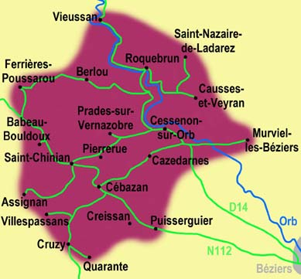
- Located between Faugeres and the better known Minervois region, St.-Chinian produces delectably spicy reds with lots of character. This wine is bright and fruity, with a serious core of pure red fruit. Yes, it is true that many famous French wines are overpriced, but as this wine shows, it is equally true that only France can consistently produce wines at this level for so paltry a sum.
- Grown on impoverished schist soils, this wine makes you think of jellied currants, crushed fresh blackberries, liquid stone, and garrigue. It is a testament to the incredible strides that have been made in the arid Languedoc, formerly the San Joaquin Valley of France’s winegrowing regions, and the dedication of one winemaker. The awesome fruit intensity and presence offered here will overwhelm you. Its thick, jammy, intoxicating nectar will have you looking for blackberry seeds at the bottom of your glass. If you love assertive fruit flavors in your wine, and if frills and finesse is not your bag, consider this wine.
- Jean-Marie Rimbert, who prunes his Carignan, Grenache, and Syrah vines aggressively, makes exceptionally dark, explosively aromatic wine.
- Syrah and Grenache are 15 years on the wine. Carignan is 50-70 years on the vine.
- Typically, 60% Carignan, 12% Syrah, 15% Grenache, etc. (e.g., Cinsault).

Savannah-Chanelle, Central Coast, California, 2000

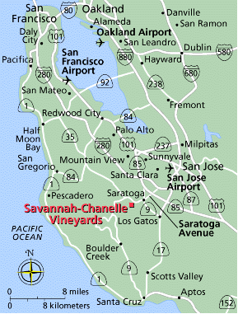
- A landmark winery in the Santa Cruz Mountains, Savannah-Chanelle Vineyards is nestled in the Redwoods along the historic "Chaine d'Or" (Golden Chain). It’s located only 3.3 miles from Saratoga.
- French immigrant Pierre Pourroy first established the vineyards in 1892. A gravity-flow winery was added to the site in 1917. Today the Ballard family carries on this turn-of-the-century legacy. Michael and Kellie Ballard purchased the property in 1996, naming it after their two daughters. The estate vineyard sits on 58 acres, with 15 acres cultivated to five award-winning varietals: Pinot Noir, Cabernet Franc, Carignane, Zinfandel, and Chardonnay. The Zinfandel plantings date to 1910, and the Cabernet Franc plantings-California's oldest--date to 1920.
- They release 350 cases a year of old vine Cabernet Franc and 450 cases a year of old vine Zinfandel, but their primary wine is Pinot Noir.
- Michael McNeill brings extensive experience from the famed Chalone Vineyard in Monterey County, and the Hinman Vineyards/Sylvan Ridge Winery in Oregon's Willamette Valley. He joined Savannah-Chanelle as winemaker in 1998.
- All of their fruit is sorted by hand before being completely destemed. Punch downs are performed by hand three times a day. After three days of "cold soak" the must is inoculated with yeast. The fermenters are drained and pressed off before dryness. By allowing the wine to finish fermenting in barrel, the oak is better incorporated into the wine. No fining is done and only a loose filtration is performed.

Le Chant du Bois, Anjou Villages, Domaine La Bergerie, France, 1999

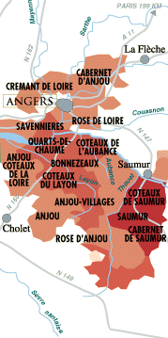
- The Anjou Villages AC comprises forty-six villages scattered throughout Anjou that produce higher-quality red wines made from Cabernet Franc and Cabernet Sauvignon.
- It has a year-round mild maritime, Atlantic-influenced climate, with light rainfall and westerly Atlantic winds. Summers are generally warm and sunny. Autumns are damp and relatively warm.
- Hard, dark rocky soils.
- This wine has muscular, with smoke and coffee notes riding over the black cherry and plum fruit. Toasty finish turns tough though, throwing it out of balance. Drink now. 200 cases imported.
- Its Wine Spectator rating is 81.
- Winemaker Yves Guégniard presents a fruit forward wine of some complexity. Flavors of black cherry, toffee, and blueberry are interspersed with elements of fried leaf and herbs, and there is NO oak to get in between your palate and all that luscious fruit. Full-bodied without being cloying, yet complicated by light tannins, this is a great summer time wine for grilled foods and beyond.

Pearmund Cellars, Virginia, 2002

- 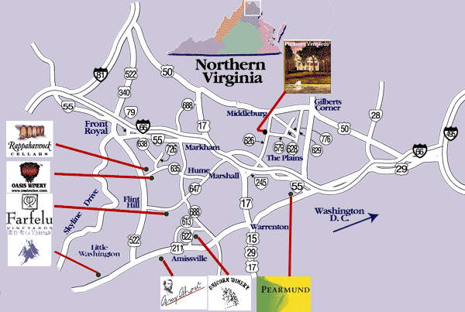Opening in June of 2003, Pearmund Cellars is one of located in the beautiful foothills of eastern Fauquier County, Virginia, near Washington, DC.
- Its wines include Estate Chardonnay, Viognier, Reisling, Late-Harvest Vidal, Cabernet Franc, Meritage, Merlot, and other varietals.
- The 2002 Cabernet Franc has herbal aromas with a touch of pepper, cherry. Its dry, medium body has a raspberry finish. It was aged in French oak barrels.

Chinon, Clos de la Cure, Loire, France, 2000

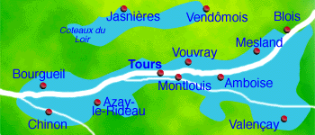
- The wine-producing area of Chinon lies in the heart of the Loire Valley and has a viticultural history that date back to the 12th century. Charles Jouget is one of the premier producers of Chinon wines, which are made almost entirely from Cabernet Franc. All of his wines are an expression of subtle elegance that pair well with food and age gracefully.
- Clos de la Cure is a very special Chinon terroir. Composed of alluvial gravel, washed down from the Massif Central by the Vienne river, the vineyard is famous for producing some of the best wine for Holy Mass in the whole of Chinon. These two hectares of Cabernet-Franc, grown on this pebbly soil with its clay base, produce a smooth, dark, fresh and fruity wine. Dark red in colour with hints of violet, the red fruit nose evolves into chocolaty flavours with hints of musk. The mouth is voluminous with soft, silky tannins. A very promising vintage that will improve with age.
- Raised out of tank stainless, the Field of the Cure 2000 is an excellent example of the honest Cabernet of the Loire. Its color is rather clear and is slightly purplished. Its nose is powerful, spiced pepper nose. Though not very vigorous, it is dry but fruity (blackcurrant, raspberry) with a good acidity and accessible tannins.
- This Chinon reveals deep plum and earthy secrets through strains of pipe tobacco.

Buttonwood, Santa Ynez Valley, California, 1999
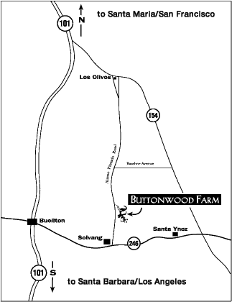
- Buttonwood Farm Winery is in Santa Barbara County's Santa Ynez Valley. Its 39-acre vineyard stretches across a sun-drenched mesa on the eastern portion of a 106-acre property.
- Buttonwood's varietal mix of Sauvignon Blanc, Semillon, Marsanne, Merlot, Cabernet Sauvignon, Cabernet Franc, and Syrah reflects the preferences of owners Betty Williams and her son-in-law, Bret Davenport, for Bordeaux and Rhone style wines. They started planting in 1983 and have 33,000 vines producing 5,000 cases of wine a year.
- Winemaker Michael Brown was educated in Australia and at the University of California, Davis. He spent six years gaining experience in Santa Barbara County before Buttonwood.
- Cabernet Franc is Buttonwood's workhorse grape. They use it primarily to blend with their merlot, as one of three components in Trevin, a Bordeaux-style blend, and, as a varietal wine.
- The 1999 growing season was cooler than usual allowing flavors to develop slowly and completely. The flavors are black cherry and bittersweet chocolate blend nicely with a toastiness from 18 months of barrel aging. This versatile food wine is capable of pairing as easily with steak as a roasted vegetable and couscous salad. 900 cases produced.
- The Cabernet Franc is deep, red/purple; dark -- not entirely closed to light; clear and free of sediments. Its aromas are deep cherry; touch of tobacco, cola, and white pepper; some toasted oak vanilla. It has good tannin structure and weight; ripe cherry fruit flavor, firm. It is slightly tart cranberry edge in the finish tempered by some wood toastiness resulting from two full years of barrel aging. This wine is well balanced and structured with a long, satisfying finish and without a lot of alcohol heat.

Bierzo, Spain, 2000
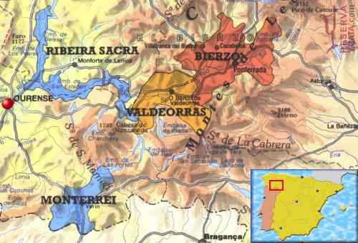
- Bierzo is a small, hilly region in the northwest of Spain, inland from Galicia and at the margins of Castilla y Leon. It is a project shared between Alvaro Palacios and his nephew Ricardo. Alvaro’s cult Grenache-based L'Ermita put the Catalan wine region of Priorat on the map. With his Bordeaux-trained nephew, he coaxed these old vineyards into life for a Descendientes de J Palacios label, named after Alvaro’s father and Ricardo’s grandfather, the patriarch of the Palacios Remondo family of Rioja who died in 2000.
- The region is rich in water and is irrigated by many rivers such as the Sil, Ancares and Burbia. Mountain ranges shelter it from the excesses of continental climate.
- Two wines are made: Corullón, from their own grapes, and regular Bierzo, from grapes in the region. Both are predominantly Mencia, the local grape that is considered to be the direct ancestor and precursor of Cabernet Franc and hails from the plantings of the earliest Roman settlers. The Portuguese claim to grow the same grape, known there as Jaen.
- The regular Bierzo wine has an opaque purple color in the glass. Its nose is sweet and quite modern, with spice and dark fruits. Its deep concentrated palate displays liquoricey fruit that meshes well with new oak. There's a fair amount of tannin hiding underneath the fruit. The wine marries savage flavors with sleek structure, offering berry, wild herb, mineral and chocolate notes. It has a long finish. Its Wine Spectator rating is 93.

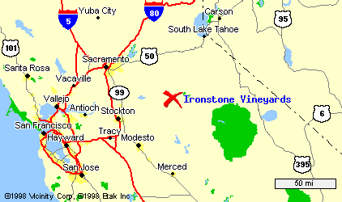
Encore: Ironstone, Calaveras County, California, 1999

Stephen Kautz is the president of Ironstone Vineyards and a director of the California Wine Institute. His family has owned their plot, once a cattle ranch, for more than 50 years. They've grown wine grapes for decades, but in 1989 they decided to dedicate themselves to viticulture, and Ironstone Vineyards was born. Today, the winery-a spectacular property that includes 10,000 square feet of underground wine caverns, an art gallery, and a culinary center-produces a quarter-million cases of wine a year and is attracting attention on the world stage.
The Sierra Foothills wine region runs from Chico in the north to Yosemite National Park in the south. On the west, it spans from the Upper San Joaquin Valley almost to the Nevada border. It is the largest officially recognized appellation in California.
Among the various wines Ironstone tackles - from Merlot and Shiraz to Chardonnay - Cabernet Franc comes up as a surprise. This unsung grape is often blended with Cabernet Sauvignon and is prized in some regions of France, especially St.-Emilion and the Loire. With 475 acres, Ironstone is "the largest producer and grape grower of Cabernet Franc in the United States," Kautz said. He favors Cabernet Franc because it doesn't have "the heavy tannin structure" of Cabernet Sauvignon. It fits in with their philosophy of making ready-to-drink wines for everyday consumption.
Ironstone’s winemaker, Steve Millier, has been involved in the wine industry for over 20 years. After graduating in 1975 from California State University, Fresno with a BS in Enology, Steve started his career as a winemaker at David Bruce Winery in the Santa Cruz mountains. He joined Stevenot Winery, in Murphys, Calaveras County in 1982 where the wines he produced won numerous awards and case sales grew from 10,000 to 50,000 in the seven years he worked there.
In 1989, Steve became the founding winemaker and Vice President for Ironstone Vineyards. Along with the superior wines he produced for the Ironstone label, he also developed several award-winning Brandies under the Creekside label. Steve is responsible for the growth to 1,000,000 gallons of storage at Ironstone. He is a founding member and past President of the Calaveras Wine Association and has been instrumental in establishing the wine industry in Calaveras County.
Steve's winemaking skills produce wines for Ironstone that have won more than 200 awards both nationally and internationally. With Steve's expertise Ironstone gained recognition for winemaking by garnering the very rare and prestigious, "Prix d' Excellence Award" from the International Du Vin at VIN EXPO 97. The winery's Meritage wine was one of only 3 American Wines awarded this designation out of 4,820 entries from all over the world.

His 1999 Cabernet Franc awards are as follows:

GOLD MEDAL  Bronze Medal  Bronze Medal  86 Points | 2002 Jerry Mead's New World Wine Festival  2002 Los Angeles County Fair  2002 Dallas Morning News  2002 Chicago Wine Challenge

See http://66.121.93.5/main.html for more information.

